

POLICY ON THE POLICE OMBUDSMAN’S CONSIDERATION OF COMPLAINTS, REFERRALS AND OWN MOTION (NON-COMPLAINT) MATTERS UNDER THE RUC (COMPLAINTS ETC) REGULATIONS 2001 AND RELATED LEGISLATION

- Introduction

1.1 The Royal Ulster Constabulary (Complaints etc.) Regulations 2001 (‘the 2001 Regulations’) list certain conditions to be met for complaints, referrals and own motion (non-complaint) matters, and certain exceptions to such conditions, before the Police Ombudsman can deal with them under Part VII of the Police (Northern Ireland) Act 1998 (‘the 1998 Act’).

1.2 The purpose of this Policy is as follows:
- to provide an overview of the approach the Police Ombudsman will take when considering complaints, referrals and own motion (non-complaint) matters under the 2001 Regulations and related legislation.
- to provide guidance to her staff in the application of the 2001 Regulations.
- to make detailed Regulations and a complex decision making process accessible to members of the public.

1.3 In having as its purpose the provision of an overview of the Police Ombudsman’s approach and a guide to members of the public, this policy is intended as an overview of the Police Ombudsman’s approach and a guide to members of her staff and the public. It does not include all conditions or outcomes under the 2001 Regulations nor does it aim to do so.

- Legal Provisions and Principles

2.1 This Policy will refer to the following UK legislation:
- Police (Northern Ireland) Act 1998 (‘the 1998 Act’)
- Royal Ulster Constabulary (Complaints etc.) Regulations 2000 (‘the 2000 Regulations’)
- RUC (Complaints etc) Regulations 2001 (‘the 2001 Regulations’)
- Northern Ireland Troubles (Legacy and Reconciliation) Act 2023 (‘the 2023 Act’)

2.2 In her application of the relevant legislation and when exercising her discretion under the 2001 Regulations, the Police Ombudsman will consider section 51(4) of Part VII of the 1998 Act which requires her to exercise her powers ‘in such a manner and to such an extent as appears to [her] to be best calculated to secure … the efficiency, effectiveness and independence of the police complaints system; and … the confidence of the public and off members of the police force in that system.’

2.3 The Police Ombudsman will consider and apply the rights pertaining to members of the public and members of the police under the European Convention on Human Rights (‘the Convention Rights’) in her application of this Policy.

2.4 The 2001 Regulations provide for a discretion on the part of the Police Ombudsman as to what she believes to be ‘the gravity of the matter or the exceptional circumstances’. Appendix A provides an overview of the approach the Police Ombudsman will take when considering such grave or exceptional matters.

2.5 In accordance with the purpose of this policy as outlined above, a Flowchart to Assist with the Interpretation of the Legal Framework has been included at Appendix B.

2.6 The six requirements under Regulation 5(3)(a)-(f), Regulation 7(2) (a)-(f) and Regulation 8(b)-(g) are identical, and are therefore considered together at Appendix C, rather than have multiple repetitions within the policy.

2.7 The Police Ombudsman notes Regulation 5 of the 2000 Regulations, which provides that ‘it is for the Ombudsman to determine what constitutes a complaint under Section (52)(8) of the Act of 1998’ subject to the exceptions as contained therein.

- Conditions to be met for Complaints under Regulation 5

3.1 Regulation 5 provides for certain conditions to met for complaints before they must be dealt with in accordance with Part VII of the 1998 Act.

3.2 Regulation 5(1) requires a complaint to be ‘made by, or on behalf of, a member of the public.’

3.3 Notably, Regulation 5(2) requires the conduct at issue to have taken place not more than 12 months before the date of the complaint (‘the 12 month requirement’).

3.4 Regulation 5(3)(a) to (f) lists six further requirements for a complaint to be dealt with in accordance with Part VII of the 1998 Act. These are considered further in Appendix C.

3.5 If the conditions under Regulation 5 are not met, a complaint may still be dealt under Part VII of the 1998 Act if it meets certain exceptions listed subsequently in the Regulations. Such exceptions for certain complaints are dealt with below.

- Exceptions for certain Complaints under Regulation 6(1)

4.1 Regulation 6(1) of the 2001 Regulations provides that Regulation 5(2) (‘the 12 month requirement’) will NOT apply where:
- the complaint is not the same or substantially the same as a previous complaint or matter, and
- where the Ombudsman believes that a member may have committed a criminal offence or behaved in a manner which would justify disciplinary proceedings, and
- the Ombudsman believes that the complaint should be investigated because of the gravity of the matter OR the exceptional circumstances.

4.2 Where a case falls under Regulation 6(1) then the Ombudsman shall investigate the complaint under section 56 of the 1998 Act (as per Regulation 6(3) of the 2001 Regulations).

- Exceptions for certain Complaints under Regulation 6(2)

5.1 Regulation 6(2) of the 2001 provides that Regulations 5(2) (‘the 12 month requirement’) and Regulation 5(3) will not apply where:
- new evidence has come to light which is not evidence which was reasonably available at the time of the original complaint, and
- the Ombudsman believes that a member may have committed a criminal offence or behaved in a manner which would justify disciplinary proceedings, and
- the Ombudsman believes that the complaint should be investigated because of the gravity of the matter OR the exceptional circumstances.

5.2 Where a case falls under Regulation 6(2) then the Ombudsman shall investigate the complaint under section 56 of the 1998 Act (as per Regulation 6(3) of the 2001 Regulations).

- Discretion for certain Complaints under Regulation 6(4)

6.1 Under Regulation 6(4) of the 2001 Regulations, the Police Ombudsman retains a discretion to investigate under section 56 (of the 1998 Act) a claim falling within Regulation 6(1) or 6(2) even when not grave or exceptional but where the belief formed by her is that the member may have committed a criminal offence.

- Conditions to be met for Referrals under Regulation 7

7.1 Regulation 7 provides for certain conditions to met for referrals by the Secretary of State, the Chief Constable or the Police Authority before they shall be considered by the Police Ombudsman under sections (1), (2) or (4) of section 55 of the 1998 Act.

7.2 Notably, Regulation 7(1) requires the conduct at issue to have taken place not more than 12 months before the date of the complaint (‘the 12 month requirement’).

7.3 Regulation 7(2)(a) to (f) lists six further requirements for a referral to be dealt with in accordance with sections (1), (2) or (4) of section 55 of the 1998 Act. These are considered further in Appendix C.

7.4 If the conditions under Regulation 7 are not met, a referral may still be dealt with in accordance with Part VII of the 1998 Act if it meets certain exceptions listed subsequently in the Regulations. Such exceptions for certain complaints are dealt with below.
8. Conditions to be met for Own Motion (Non-Complaint) Matters under Regulation 8

8.1 Regulation 8 provides for certain conditions to met before the Police Ombudsman shall be able to consider a formal investigation of any own motion (non-complaint) matter under section 55(6) of the 1998 Act.

8.2 Notably, Regulation 8(a) requires the conduct at issue to have taken place not more than 12 months before that time (‘the 12 month requirement’).

8.3 Regulation 8(b) to (g) lists six further requirements for an own motion (non-complaint) matter to be dealt with in accordance with section 55(6) of the 1998 Act. These are considered further in Appendix C.

8.4 If the conditions under Regulation 8 are not met, an own motion (non-Complaint) matter may still be dealt with under section 55(6) of the 1998 Act if it meets certain exceptions listed subsequently in the Regulations. Such exceptions for certain own motion (non-complaint) matters are dealt with below.

9. Exceptions for certain matters (Referrals and Own Motion (Non-Complaint) Matters) under Regulation 9

9.1 Regulation 9(1) of the 2001 Regulations provides that Regulation 7(1) and 8(1) (‘the 12 month requirement’) will NOT apply in relation to referrals or own motion (non-complaint) matters where:
- the matter is not the same or substantially the same as a previous complaint or matter, and
- where the Ombudsman believes that a member may have committed a criminal offence or behaved in a manner which would justify disciplinary proceedings, and
- the Ombudsman believes that the complaint should be investigated because of the gravity of the matter OR the exceptional circumstances.

9.2 Regulation 9(2) of the 2001 Regulations provides that Regulation 7 and 8 will NOT apply in their entirety in relation to referrals or own motion (non-complaint) Matters where:
- new evidence has come to light which is not evidence which was reasonably available at the time the matter originally occurred, and
- where the Ombudsman believes that a member may have committed a criminal offence or behaved in a manner which would justify disciplinary proceedings, and
- the Ombudsman believes that the complaint should be investigated because of the gravity of the matter OR the exceptional circumstances.

9.3 Where a matter falls under Regulation 9(1) or 9(2) then the Ombudsman shall investigate the referral or own motion (non-complaint) matter under section 56 of the 1998 Act.

9.4 Under Regulation 9(4) of the 2001 Regulations, the Police Ombudsman retains a discretion to investigate under section 56 (of the 1998 Act) a referral or own motion (non-complaint) matter falling within Regulation 9(1) or 9(2) even when not grave or exceptional but where the belief formed by her is that the member may have committed a criminal offence.

9.5 If any conduct to which any referral or own motion (non-complaint) matter wholly or partly relates is or has been the subject of disciplinary or criminal proceedings then the Police Ombudsman has no powers in relation to the matter in so far as it relates to that conduct.

10. Decision Making Process

10.1 The Police Ombudsman has delegated decision making authority for non-troubles related matters from 1 January 1966 to 31 December 2006 under this policy to her Director of Legacy.

10.2 The Police Ombudsman has delegated decision making authority for post 1 January 2007 matters under this policy to her Director of Current Investigations or her Director of Impact.

10.3 If the relevant Director determines that a complaint meets the relevant requirements of the 2001 Regulations then it will be passed for investigation under section 56 of the 1998 Act.

10.4 If the relevant Director determines that a referral meets the relevant requirements of the 2001 Regulations then it will be passed for investigation under section 56 of the 1998 Act, subject to the Police Ombudsman’s consideration of whether it is desirable in the public interest to do so, where applicable under section 55(5) of the 1998 Act.

10.5 If the relevant Director determines that a matter meets the relevant requirements of the 2001 Regulations for own motion (non-complaint) matters under Regulation 8 or 9 and that the matter is one which the Police Ombudsman may wish to consider under section 55(6) of the 1998 Act, then they will pass the matter to the Police Ombudsman for such consideration.

10.6 Delegation of authority in relation to the above is made in accordance with the Office’s Delegation of Authority scheme. The Police Ombudsman retains the right to consider a particular matter herself or to delegate authority to an alternative Director, as per the said scheme, depending on staff availability or the particular circumstances of a case.

11. Publication

11.1 This policy will be publicly available on the Police Ombudsman’s website.

11.2 A copy of this policy will be shared with members of the public whose complaint does not meet the 12 month requirement under Regulation 5(2) of the 2001 Regulations.

12. Review

12.1 This policy will be reviewed every three years or more frequently if necessary.

Marie Anderson
Police Ombudsman for Northern Ireland
June 2024

Appendix A
Police Ombudsman’s Approach to Condideration of
Grave or Exceptional Circumstances

- Introduction:

A1.1 This Appendix will provide clarification and consistency in the decision making process to be taken by the Police Ombudsman in relation to her interpretation of the grave or exceptional requirement under the 2001 Regulations.

A1.2 Regulations 6(1), 6(2), 9(1) and 9(2) of the 2001 Regulations include the relevant requirement as follows, that:
‘the Ombudsman believes that the matter should be investigated because of the gravity of the matter or the exceptional circumstances.’

A1.3 The Police Ombudsman therefore has discretion in her interpretation of this requirement. This Appendix will further provide clarification and consistency in the Police Ombudsman’s exercise of such discretion.

- Legal Provisions and Principles

A2.1 The Police Ombudsman will adhere to the legal provisions and principles as referred to in Chapter 2 of this policy in her interpretation of the grave or exceptional requirement.

A2.2 The Police Ombudsman is cognisant of the limited resources available to her Office and will prioritise ensuring that oversight of the contemporary police service is efficient, effective and independent, and that the public and members of the police force will have confidence in such a system of oversight.

A2.3 In light of the requirements of section 51(4) of the 1998 Act, it is the Police Ombudsman’s view that the more recent a matter which comes to her attention under the 1998 Act, the more likely it will impact on the confidence of the public and members of the police in the police complaints system, and therefore the more likely that it will be that it is considered sufficiently ‘grave or exceptional’ that it should be investigated. She will therefore prioritise more recent cases over those of a greater vintage in her interpretation of this requirement. The former will generally be likely to be have fewer investigative difficulties, more readily available evidence and a greater likelihood that the officers concerned may remain serving, while such factors are less likely to apply for more distant matters.

A2.4 The Police Ombudsman will consider that the more distant the allegations made against a member of the police, the more grave or exceptional the matter will need to be before she considers that it should be investigated.

A2.5 Each case will be considered on its own merits. While this Appendix will guide the Police Ombudsman in her application of the legislation, it will not be binding on her and she, or those with delegated authority, will retain such discretion in relation to each individual case.

- Gravity of the Matter

A3.1 The Collins Dictionary defines ‘the gravity of a situation or event is its extreme importance or seriousness.’ Black’s Law Dictionary (11th Edition) defines ‘gravity’ as ‘seriousness of harm, an offense, etc., as judged from an objective legal standpoint.’

A3.2 The Police Ombudsman will avail of the following as initial guidance and as a starting point in her consideration of the gravity of a particular matter:
- The conduct of a relevant member led to the death or serious injury of a member of the public. ‘Serious injury’ shall be one as defined by section 50 of the Act;

- A relevant member committed (or attempted) a serious assault or serious sexual offence;

- A relevant member is guilty of serious corruption;

A3.3 The Police Ombudsman will further consider the serious consequences of the alleged criminality or misconduct for the complainant, for instance the loss of livelihood, bankruptcy or impact on home and family life.

A3.4 Following the introduction of the 2023 Act, the Police Ombudsman retains responsibility for the investigation of members of the police for non-troubles related matters from 1 January 1966 to 10 April 1998. In such cases, ‘the gravity of the matter’ will normally, but not exclusively, involve an allegation of RUC involvement in the death of a person, whether by direct or indirect involvement, or in some circumstances as a result of a failure on their part to effectively investigate a death. It may also be the case that, although not involved in a death, the allegations against officers involve such a widespread and consistent element of criminality that, in all the circumstances, the matter would be considered as grave.

- Exceptional Circumstances

A4.1 The word ‘exceptional’ is defined by the Collins Dictionary as ‘someone or something that has a particular quality, usually a good quality, to an unusually high degree’ or ‘situations and incidents [that] are unusual and only likely to happen very infrequently.’ While Black’s Law Dictionary (11th Edition) is silent on the word ‘exceptional’, it defines ‘exceptionalism’ as ‘the state or condition of being different from the norm’.

A4.2 It is the Police Ombudsman’s view that it not possible to conclusively determine what will constitute ‘exceptional circumstances’ and each case should be considered on its own particular merits.

A4.3 The Police Ombudsman will consider how long the complainant has or should reasonably have been aware of the criminality or misconduct alleged in her consideration of ‘exceptional circumstances’. There may be circumstances where the complainant only became aware of the alleged criminality or misconduct after the expiration of the 12 month time limit. This will be relevant in such considerations, while the time taken thereafter for a complainant to make a complaint, and whether this was within 12 months from them being made aware of the conduct concerned, will be relevant factors in making a decision.

Appendix B

Flowchart to Assist with the Interpretation of the Legal Framework

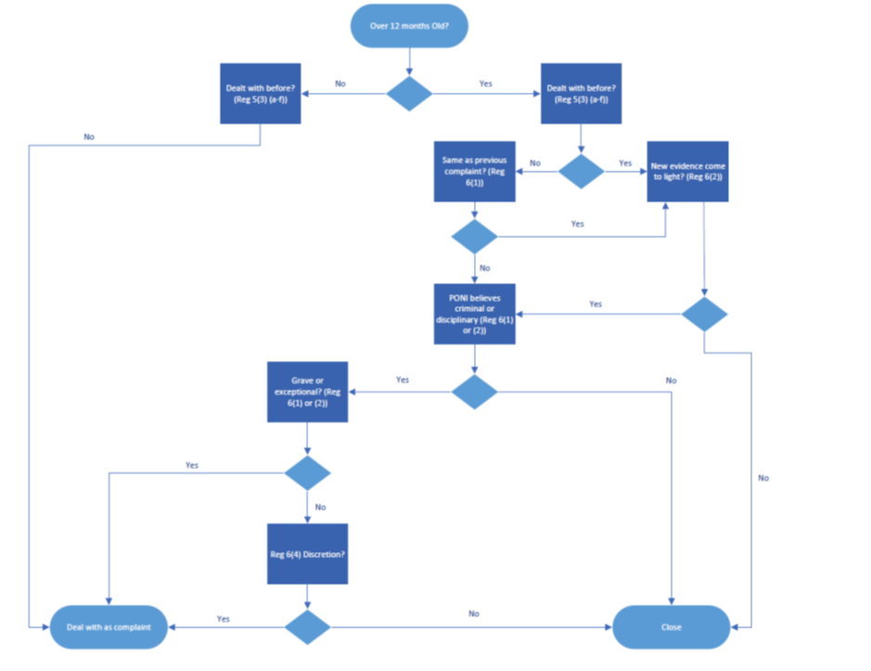

Appendix C

Requirements under Regulation 5(3)(a)-(f), Regulation 7(2) (a)-(f) and Regulation 8(b)-(g)

C1.1 A statement has not been issued in respect of the disciplinary aspects of an investigation by the Independent Commission for Police Complaints for Northern Ireland (under Article 9(11) of the Police (Northern Ireland) Order 1987 (‘the 1987 Order’)) or by the Police Ombudsman sending the appropriate authority a memorandum (under section 59(2) of the 1998 Act);

C1.2 the complaint has not been informally resolved by the investigation of a complaint against officers, other than senior officers (in accordance with Article 5 of the 1987 Order) or by informal resolution (under section 53 of the 1998 Act);

C1.3 the matter has not been withdrawn by the complainant, his solicitor or other authorised agent (within the meaning of Regulation 16 of the Royal Ulster Constabulary (Complaints etc) Regulations 1988 (‘the 1988 Regulations’) or Regulation 23 of the Royal Ulster Constabulary (Complaints etc) Regulations 2000 (‘the 2000 Regulations’)),

C1.4 the matter has not been dispensed with as anonymous, repetitious or incapable of investigation (under Regulation 17 of the 1988 Regulations) or as anonymous, repetitious, vexatious, oppressive or otherwise an abuse of the procedures for dealing with complaints or incapable of investigation (under Regulation 25 of the 2000 Regulations);

C1.5 the matter has not been otherwise dealt with by a tribunal constituted or person appointed under the Regulation of Investigatory Powers Act 2000 (under regulations made under 64(2)(d) or (e) of the 1998 Act); or

C1.6 the matter has not been otherwise investigated by the police.

